Book Buzz

Work with your partner or group, using the questions below to discuss the book you are reading.
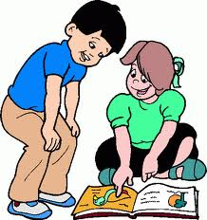

Who is the most important or interesting character and why?

What is the setting? Why is the setting important to the story?

What do you know about the plot so far?

What questions would you ask the author if you could?

What new or interesting words have you found?

Read a selection as though you were the main character.

Discuss what makes this a fiction or a non-fiction book.

What type of person enjoys this book and why?

Discuss the title of your book.

Would you recommend this book? Why? Why not?

Finish this sentence: This book reminds me of….

Make a prediction what do you think will happen next.

Discuss a recommendation you have for the author.

Retell your favourite part of the story.

Compare/ contrast two characters in your story.

Rate the book out of ten.

