Drawing a Picture
What can I draw a picture of?
The main character
My favourite character
The main event in the story
The front cover
Rule:
Try my best
Use lots of colours
Take my time

Worksheet Table
Take my worksheet that is with my book.
Try my best to complete it before time is up.
Do not ask teacher for help.
Ask somebody on your table for help.
If you can’t answer it continue you onto the next one.
Keep my work neat.
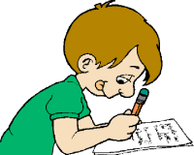

Guided Reading Table
Listen to each other read.
Use expressive tones.
Learn about different reading strategies.
Read as best as I can.
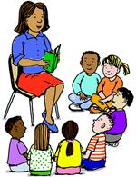

Mini Lesson Table
Listen carefully to teacher.
Try and answer as best as you can.
Try and complete my work.
Keep it neat.
